
Course: Mobile Application System and Design Date:6 Feb 2026

Group Members: • Aline NIYONIZERA: 223009117
• Gaetan UWIZEYIMANA: 222008181

Dart Programming Lab1 Report
This document presents explanations and outputs for each question (Q1–Q20) implemented in the Dart School Management System project.

Q1
This question demonstrates a simple Dart function used to display a welcome message. Functions help organize code into reusable blocks, improving readability and maintainability.
output:
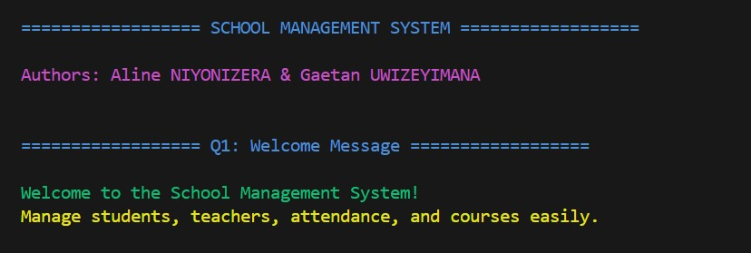

Q2
This question shows the use of a function with named parameters to create a student. Named parameters improve clarity when calling functions.
Output:
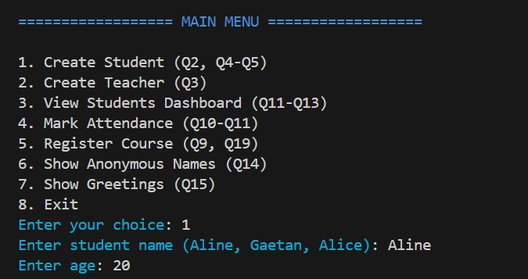

Q3
This question demonstrates optional parameters in Dart functions. Optional parameters allow flexibility when some data is not mandatory.
Output:
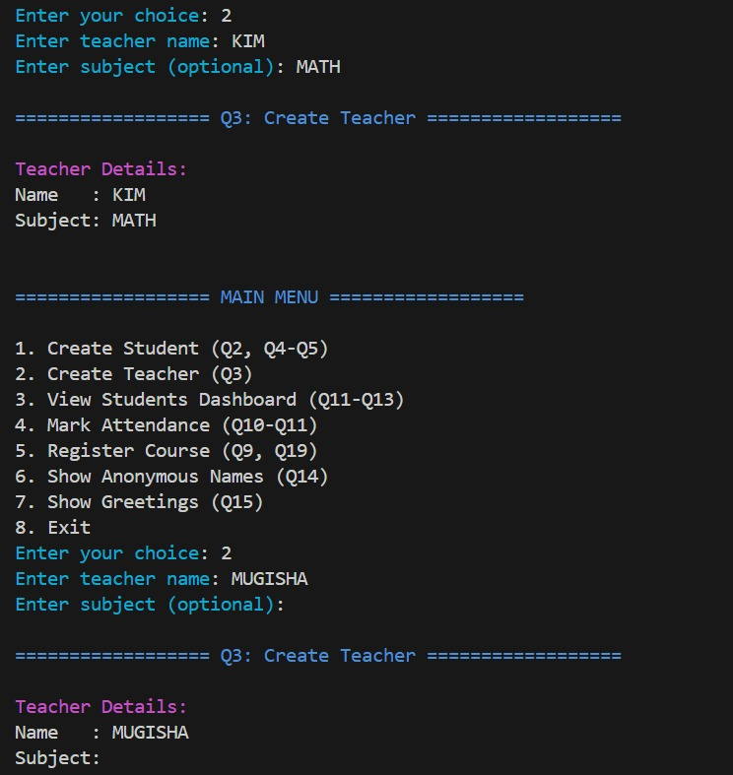

Q4–Q5
These questions demonstrate the use of classes and constructors. A class is a blueprint for creating objects, while constructors initialize object data.
Output:
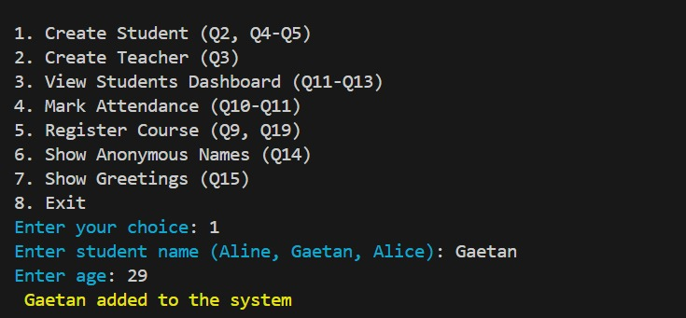

Q6
This question introduces a class named Person. A class groups data and behavior together, representing real-world entities in code.
Output:
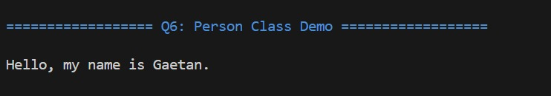

Q7
This question demonstrates inheritance where Student extends Person. Inheritance allows a class to reuse properties and methods of another class.
Output:
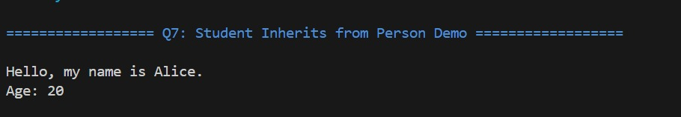

Q8
This question introduces interfaces using abstract classes. Interfaces enforce a contract that implementing classes must follow.
Output:
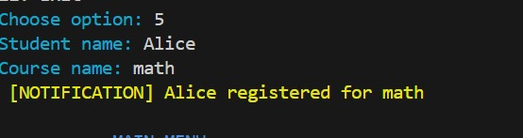

Q9
This question demonstrates course registration functionality. It shows how methods can represent real system actions.
Output:

Q10–Q11
These questions demonstrate mixins for attendance tracking. Mixins allow sharing functionality across classes without inheritance.
Output: 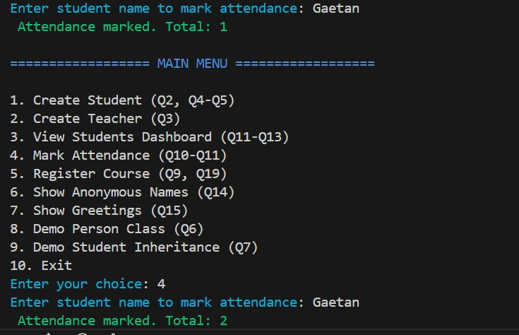

Q12
This question demonstrates the use of a List collection. Lists store ordered data and are useful for managing multiple objects.
Output:

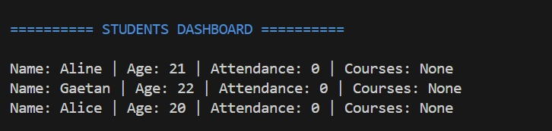Q13
This question demonstrates the use of a Map collection. Maps store key–value pairs and are useful for fast data lookup.
Output:
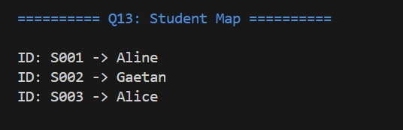

Q14
This question demonstrates anonymous functions. Anonymous functions are functions without names, commonly used for short operations.
Output:
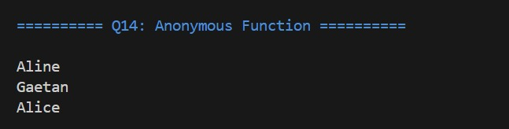

Q15
This question demonstrates arrow functions. Arrow functions provide a concise syntax for simple functions.
Output:
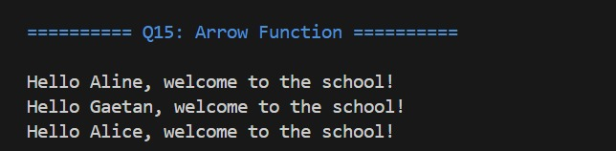

Q16
This question demonstrates asynchronous functions using async and await. Async functions allow non-blocking operations such as loading data.
Output:

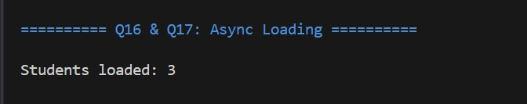Q17
This question demonstrates awaiting asynchronous results. Using await ensures that data is fully loaded before use.
Output:

Q18
This question explains mixins versus inheritance. Mixins add reusable behavior, while inheritance models an 'is-a' relationship.
Feature | Inheritance | Mixins
Relationship | “Is-a” relationship (subclass → parent) | No “is-a” relationship; just adds features
Code Reuse | Reuses parent class properties/methods | Adds reusable behavior without hierarchy
Multiple Use | Single inheritance (Dart allows single class inheritance) | Can be applied to multiple classes easily
Purpose | Define a class hierarchy | Add functionality to existing classes
Flexibility | Less flexible; bound by hierarchy | More flexible; can mix in only what’s needed
Example | class Student extends Person | class Student with AttendanceMixin

Q19
This question introduces NotificationMixin. The mixin provides notification behavior without altering the class hierarchy.
Output:

Q20
This question explains the relationship between Dart and Flutter. Understanding Dart is essential for building Flutter applications effectively.
Learning Dart helps understand Flutter because Flutter apps are written entirely in Dart.
Concepts such as functions, classes, objects, constructors, collections, async programming, and mixins in Dart are directly used in Flutter development.
Understanding Dart makes it easier to create widgets, manage state, and handle user interactions in Flutter.
We learned that mastering Dart is essential to efficiently building robust and responsive Flutter apps.

